Amazon CloudFront is an economical but a dynamic content delivery network (CDN).

It enables you to enhance the experience of users accessing both static and dynamic content of your website.

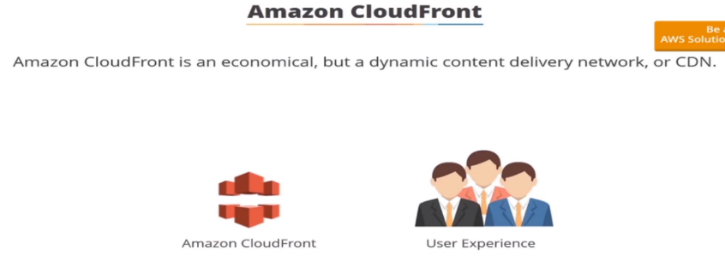

Amazon CloudFront administers an association of edge locations to store copies of frequently accessed files in proximity to its users…

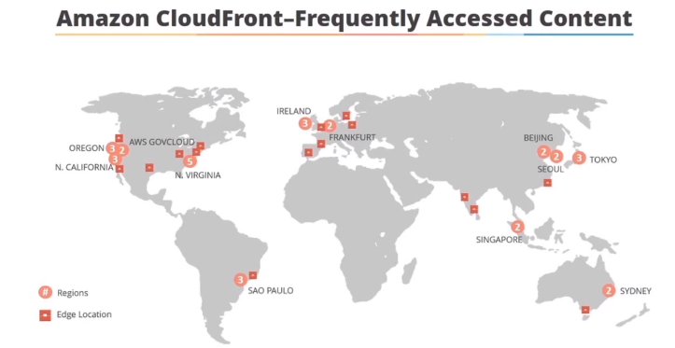

For a definition edge locations refer to the boundaries between locations of major cloud servers, when a visitor requests the desired content whether it is dynamic or static or streaming….

Amazon CloudFront makes it available from the nearest network of edge locations.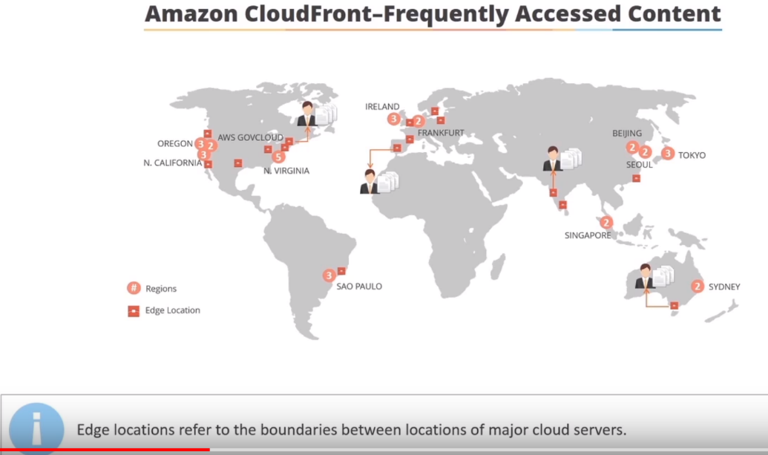

This results in objects traveling shorter distances thereby improving website performance.

But what about files that are not cached ????

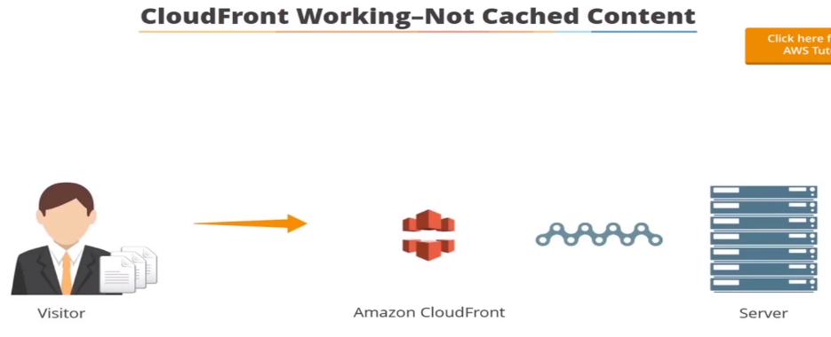

Amazon CloudFront continues to maintain connection with servers that originally host content files.

So when a visitor requests content Amazon CloudFront ensures that the requested objects reach the visitor immediately.

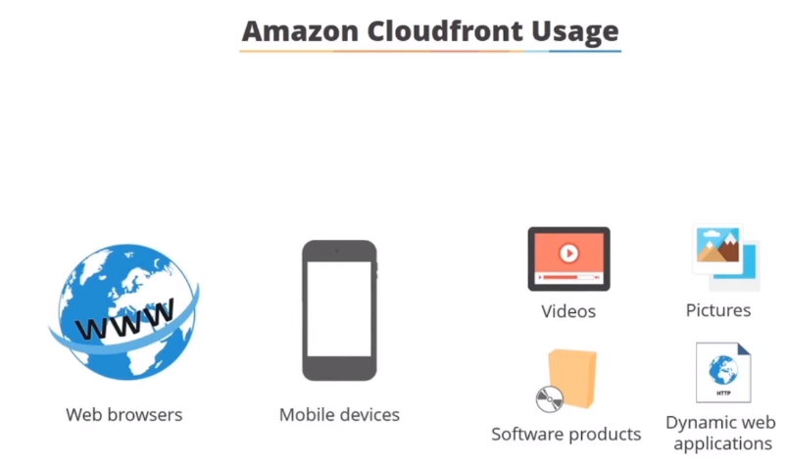

Amazon Cloud Front supports users requesting data using both web browsers and mobile devices.

Unlike Amazon glacier the solution is an ideal choice to distribute the frequently access static and dynamic content such as videos pictures software products and dynamic web applications over HTTP.

The two key advantages of utilizing Amazon CloudFront are its ability to scale according to your requirement and the flexible cost model.

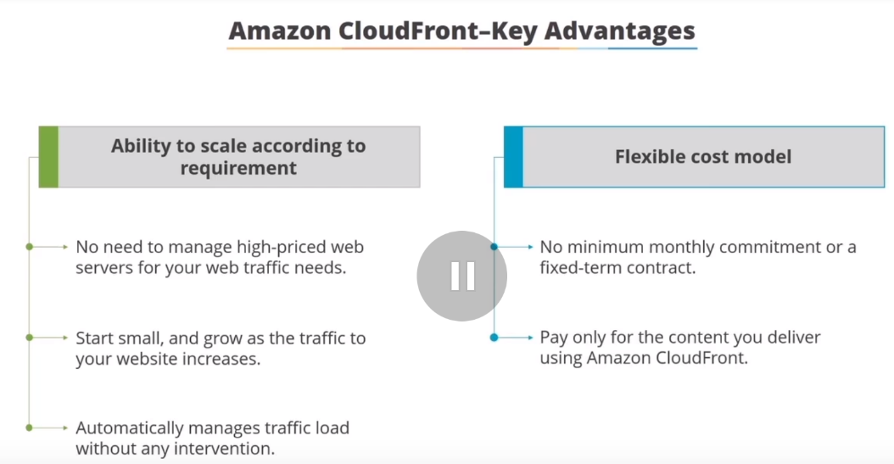

**AWS - Set up new CloudFront Distribution with S3 bucket – Demo**

We have different edge locations across world..These edge locations are used by CloudFront (Amazon CDN service) to cache assets

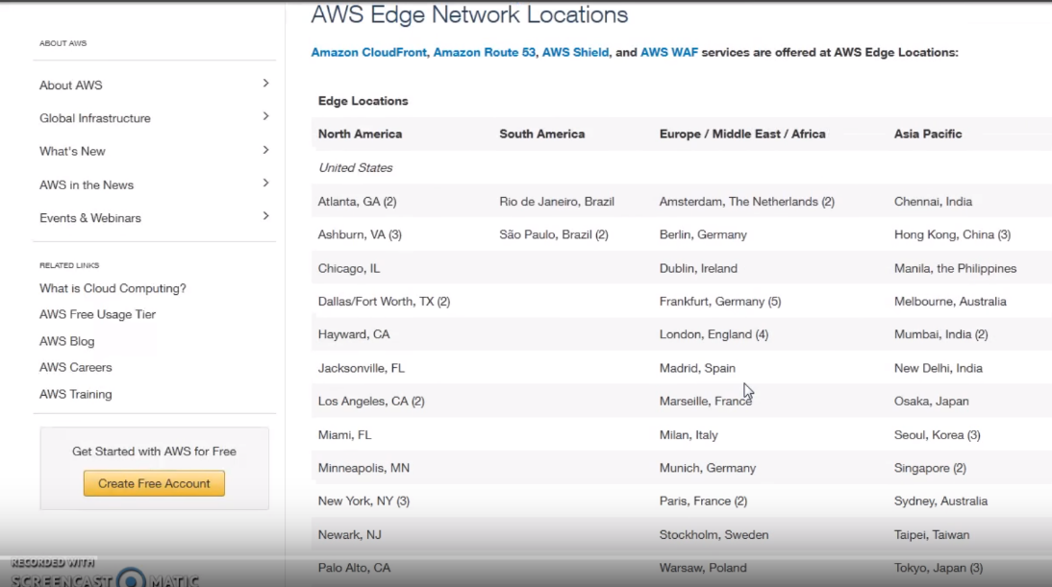

Lets say we have a website hosted outside region..Lets say hosted out of London..

We have S3 bucket, where css files, java script files, html are stored. Now, if we serve website using CLoudfront, people accessing website from Australia, US ..Website is served from one of edge locations near to them..

Cloudfront is able to cache these assets and add edge locations… Hence repeated cache doesn’t happen from London to Austrialia..Rather it gets cached at edge locations and quickly downloaded to subsequent users..

**Demo**

1.)On S3 buckt, I have logo.jpg and index.html files..

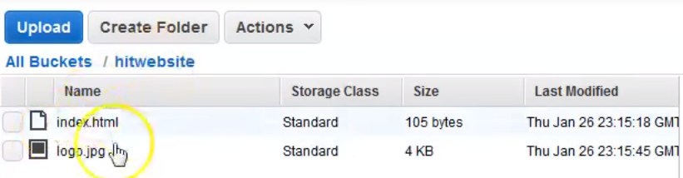

2.)Goto Cloudfront🡪create Distribution

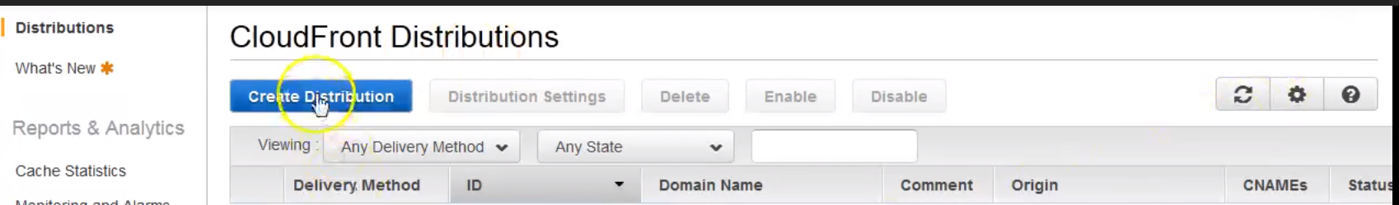

3.)Cloudfront support 3 types of protocols.

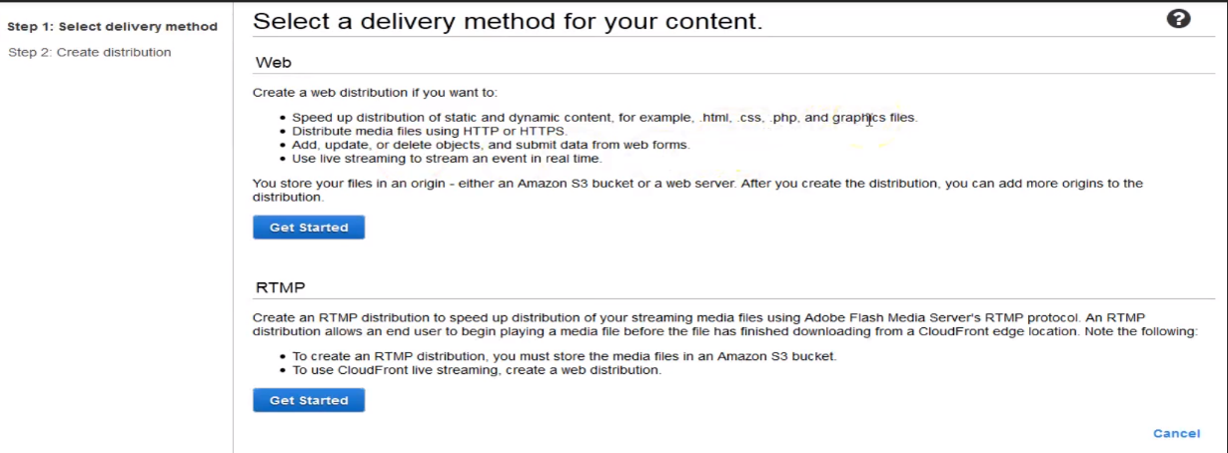

**Web:** .html,.css,.php files

**RMTP:** Streaming purpose…hosting audio, video

4.) Choose Web… It will show all ELB and S3 in Origin Domain Name..

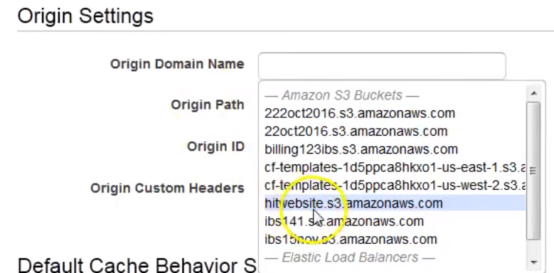

Origin Domain Name...: Choose S3 bucket

Origin Path: If my folder is inside my bucket…I must give path like /folder…

In this case, files are at beginning of S3 bucket... So leaving as blank...

Origin ID: It will get auto-generated…Or give some name to remember like Origin...

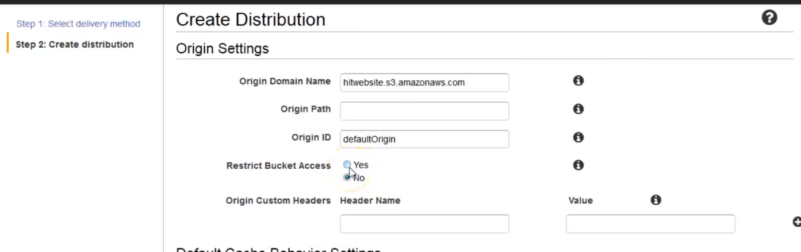

**Restrict Bucket access:** Yes ..Default No.

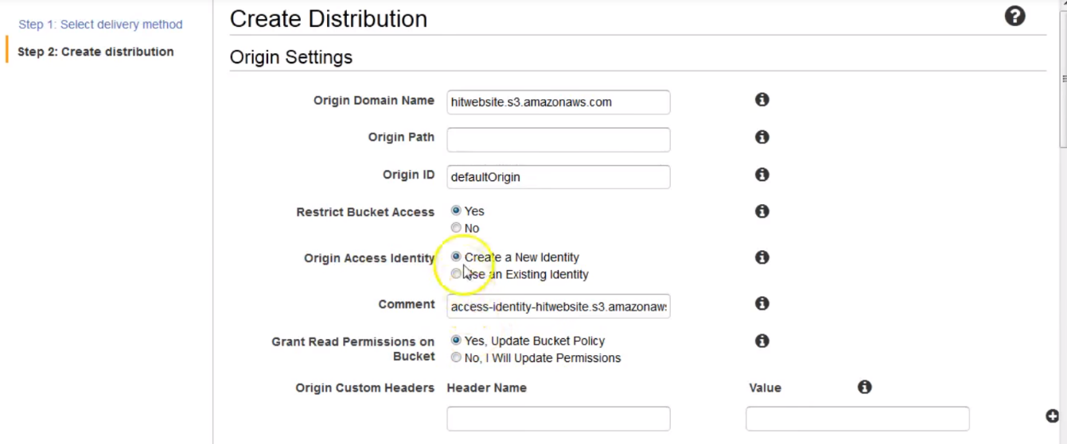

A new identity will get created for CloudFront. Only CloudFront will allow be allowed read content from S3 bucket. But nobody else can access form S3 bucket. For this S3 bucket policies will be updated…

**Grant Read Permission**: Yes, Update Bucket policy.

**As part of CloudFront, we create Default cache and Origin…**

There is another video where we can use 2 origins and 2 defaults to setup static and dynamic content behind CF distribution..

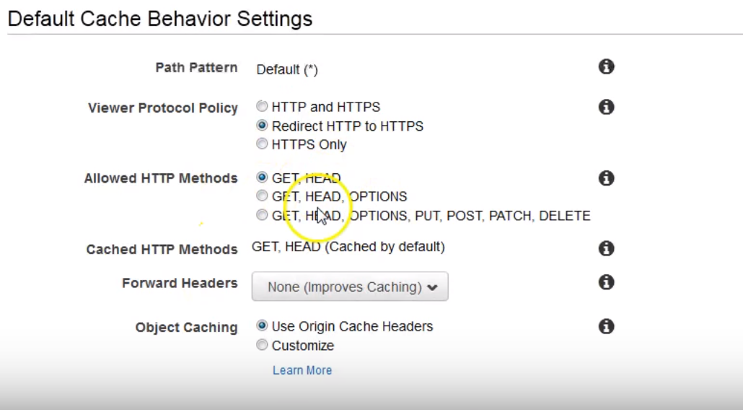

Redirect http to https.

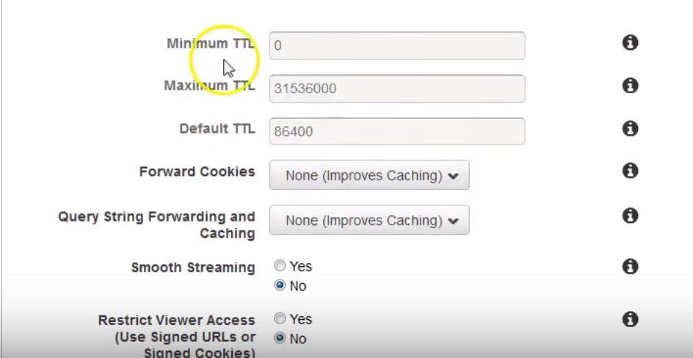

How much you want to cache: Default ---86,400 sec (24 hrs)

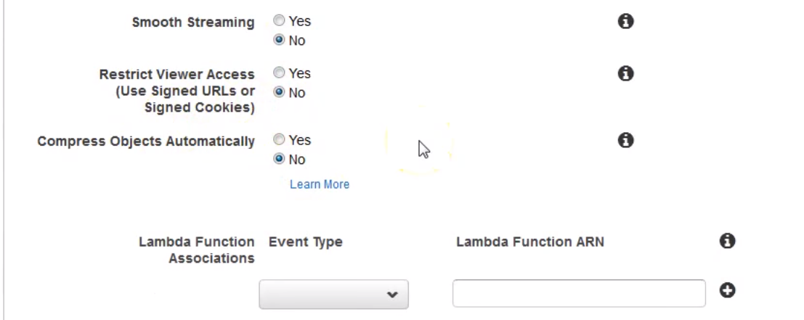

Streaming: We are not doing here…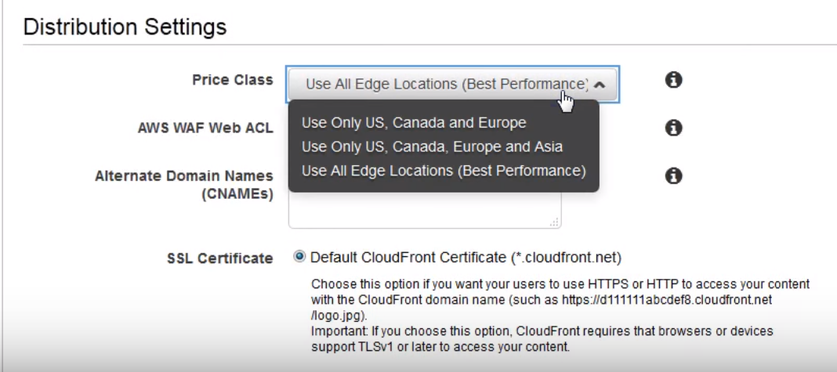

If you think, user comes all over world…Select Use All

AWS WAF Web ACL: Firewall. If we want to use firewall in front of CF.. Ex: For DDOS attacks.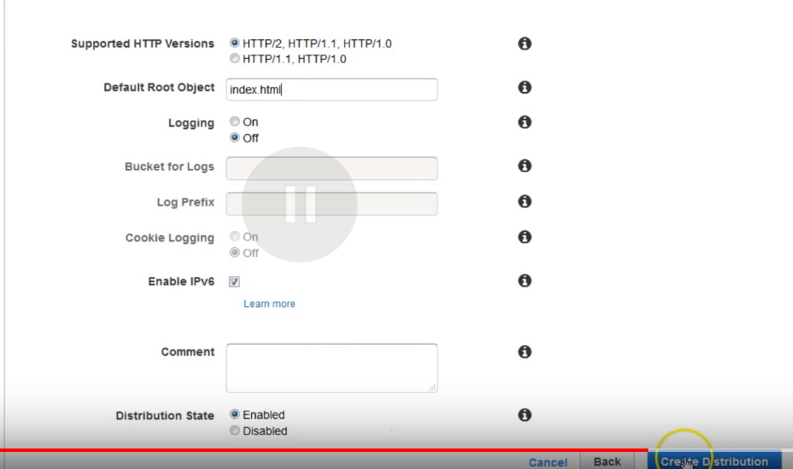

Default Root object: If a wrong url is typed…Where should I redirect to

Logging: Enable logs?

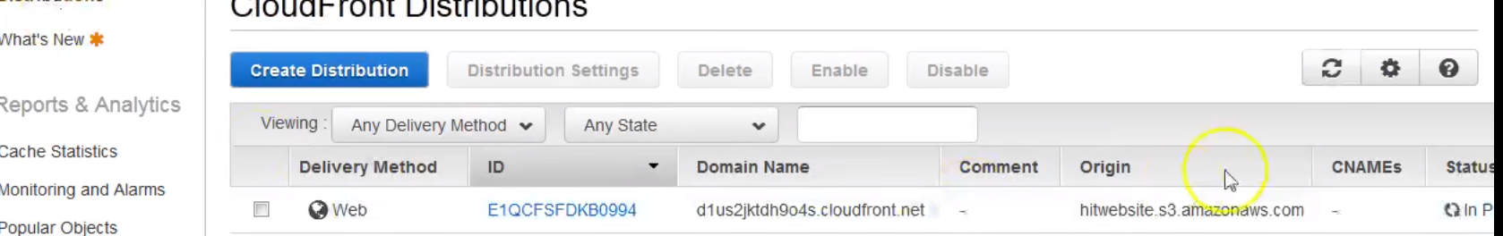

If we look at bucket policy:

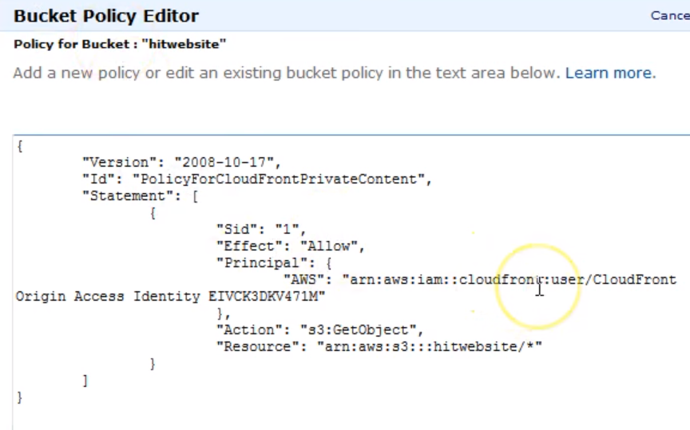

Note: We chosen only CF user can only access contents from this bucket…

For this bucket policy have been updated …Created Cloudfrom user…And only Allow for Cloud front user..Get_objets allowed for him…

DEMO-2:

How to serve static as well as Dynamic Content using CF

Any website will have static and dynamic assets…Ex: css, java script, images, ausio,video..All are stsatic

Dynamic: Video🡪 wich needs processing from server side.

Ex: Lets say you have website hosted in London region..And you have static assets stored in S3 bucket, which is also in London region.

You have got users coming from US, and Australia as well.

If we use CF for static assets, then static assets get served from Edge location in US to US users and from Edge location Austalia to Australia users.

But Dynamic content travel from public network London to US and Australia.

If we start serving Dynamic content using CF …Good thing would be traffic would leave Amazon n/w only from Edge location which is near to Customer.

**Ex: If customer is accessing webite from Australia, traffic for dynamic one travels from London to Australia on AMaozn n/w and leave AMaozn n/w only on Edge location which is in Australia near to customer…**

1. It will help in speed -wise ..because of better n/w …
2. Lower Costs.  **If we look at Data-out charges of ELB or Ec2 instance, compared with data out charges of CF,**

**data out charges offers lower data out charges…**

**We can also do reservations of data out . So we can lower further cost…**

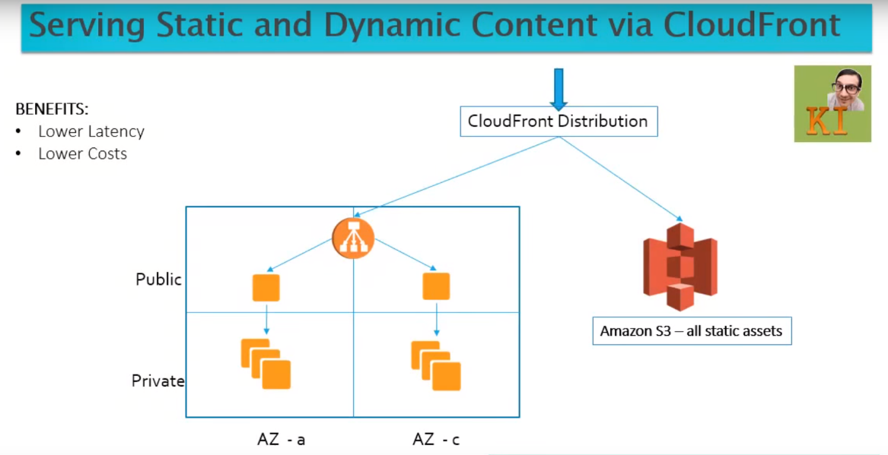

Elb with Ec2 instances in Private subnet…These Ec2 instances have all static assets, which is stored on S3.But it doesn’t access Static assets via S3 urll…Rather they are accessed via CloudFront URL..

In our VPC, we have 4 subnets…2 public, 2 private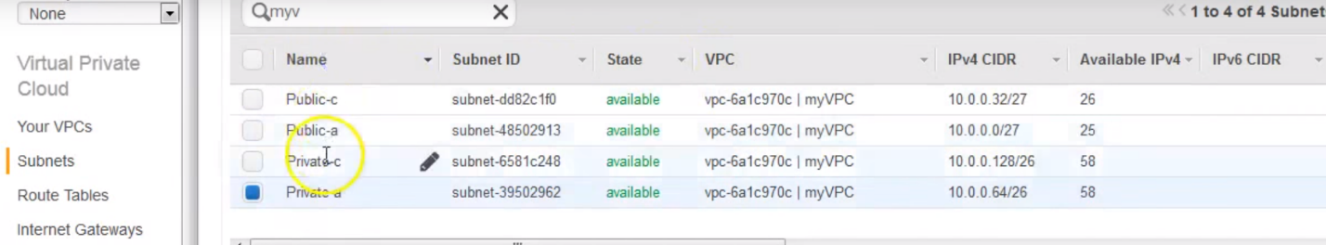

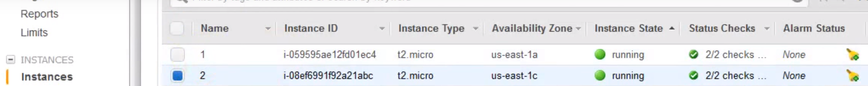

2 servers in private subnet(private IPs)… …2 instances registered with ELB

Accessing via ELB URL…

.

This ELB is in N.Virgina..From there it travels all along world through public internet..

Do page source …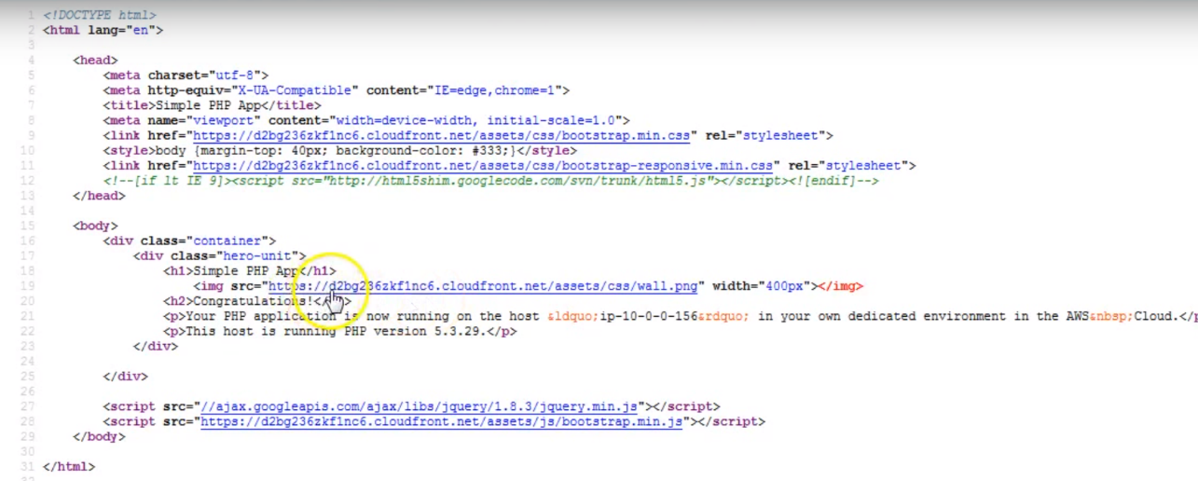

It have css, java script and png files…

All of these are accessed from Cloudfront URl..,

To undertand: Lets say this website is hosted in N.Virgina.., and I access it from Australlia.So the dynamic content is travelling from N.virgina to Australia on public n/w…

But I am using images on CF. But all of these static things got downloaded from edge locations in Australia near to me..

--🡪I want to serve complete website, even dynamic page from CF url…Hence I want to ensure that it doenst travel from N.virgina to Australia on public n/w…rather it comes from CF url from near by edge locations near to Me…

**DEMO:**

1.)I have this s.js file accessed using CF urll…not using S3 url

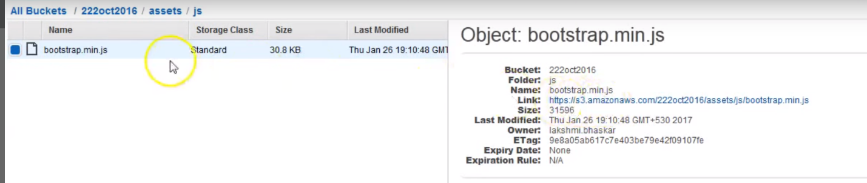**2.)On CF distribution, I have 2 origins…**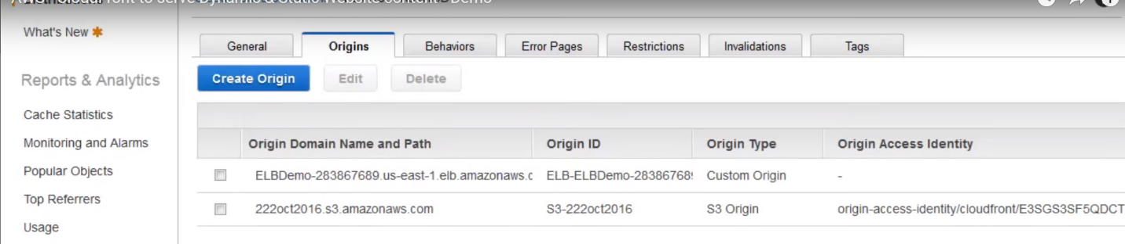

**(traffic is gonna served by an elb and S3)**

**…So these are 2 origins I have**

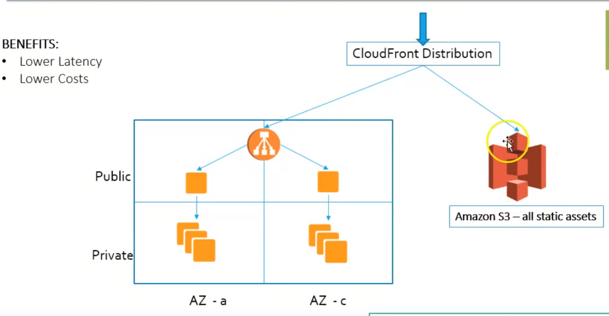

**Origin-1: For ELB properties**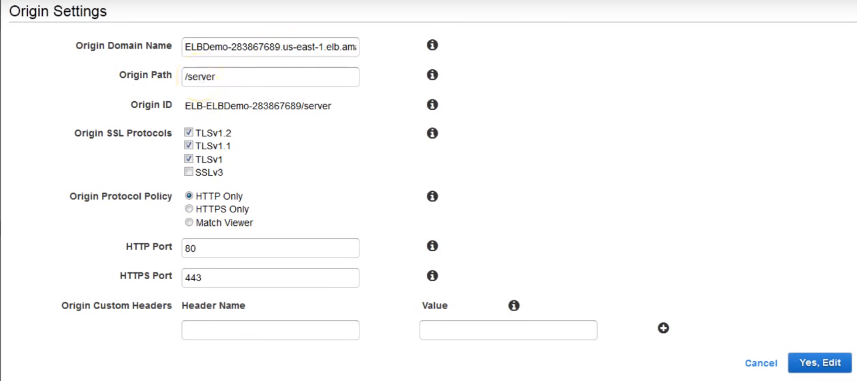

**Origin DomainName: Elbname**

**Origin path: /server because…url I was accessing is /server/index.php**

**ELB running on port 80**

**Origin-2:**

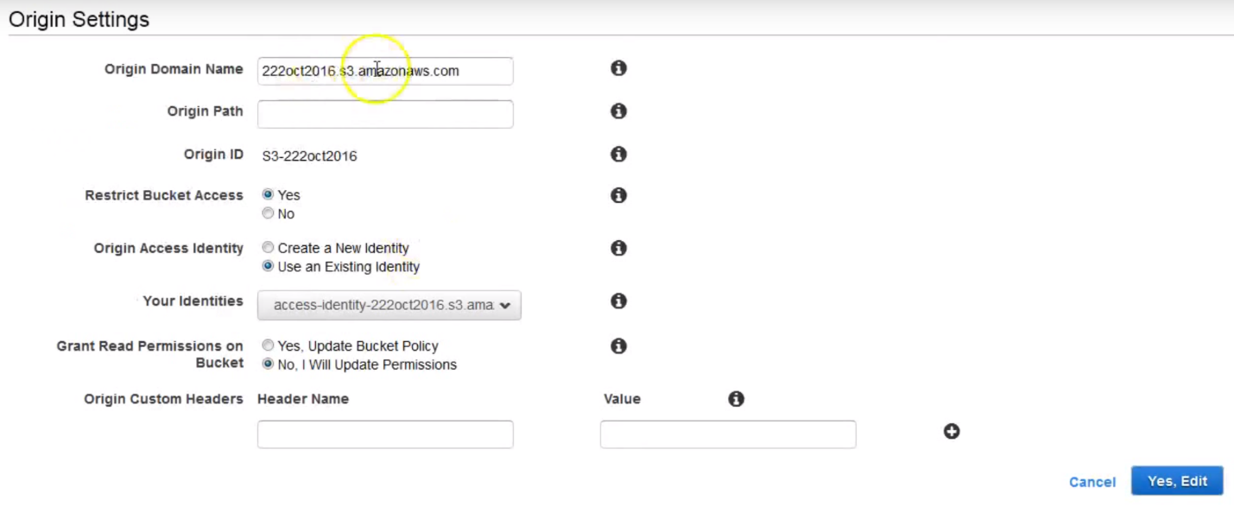

**I have restricted access,so only CF user can access from bucket and not everybody else…**

**Even if somebody have S3 url…they cannot access objects**

1. **Setting Up behavior**

I have to send all php to ELB and css, jpg to S3…

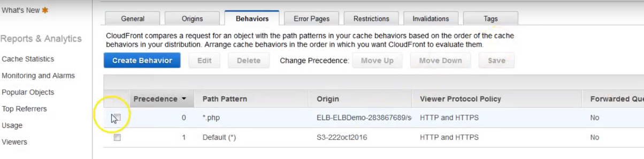

I have created behavior for this…

a.)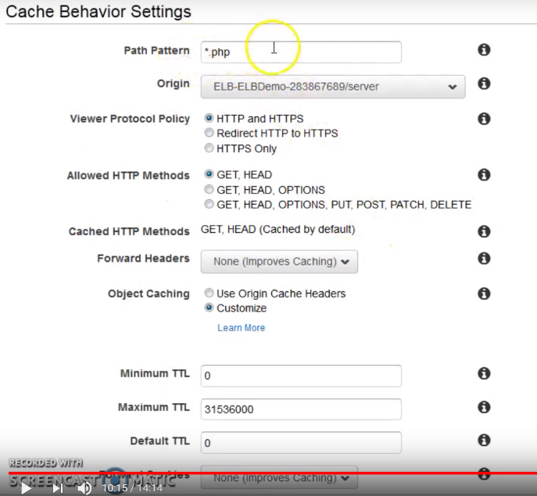

For Anything of *.php -🡪 send to ELB origin

Note: 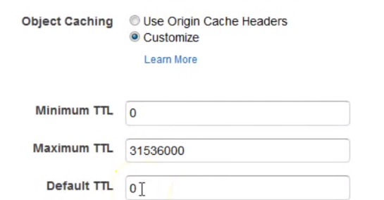

I have set cache=0…I don’t want to cache at CF level…Any request that comes and that is of Dynamic nature send it to ELB..Dont cache…

b.)priority-2

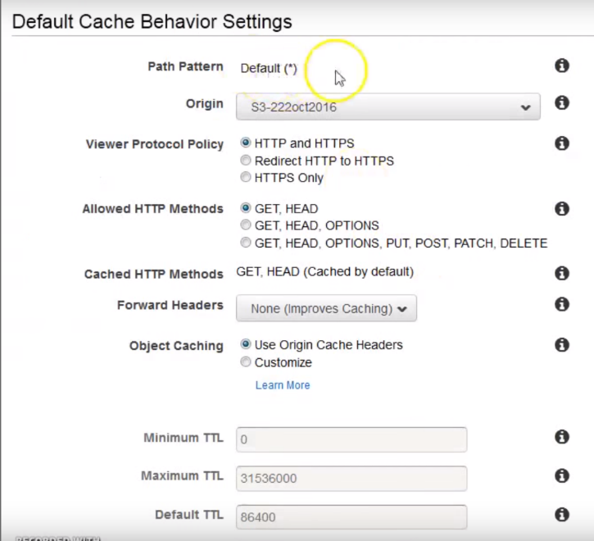

Anything withis left over is handled by this…

**In this way, we can do N dynamic things** and 2/3 S3 bucckets …And create N number of Origins here…

Since it is static, I have sent TTL(time to live) 24 hrs.

1. 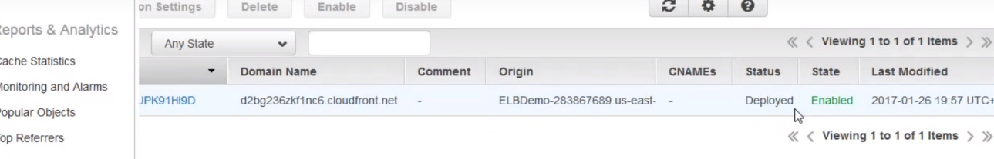

Whenever here is change it takes 10-15 min…STATE--DEPLOYED

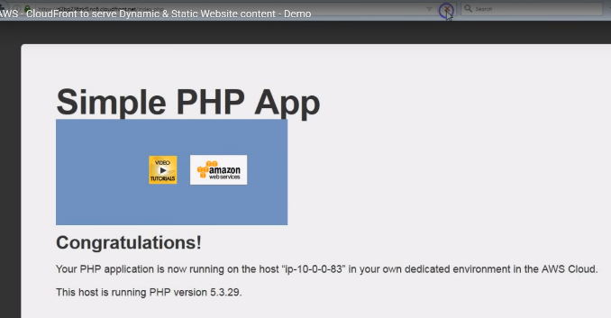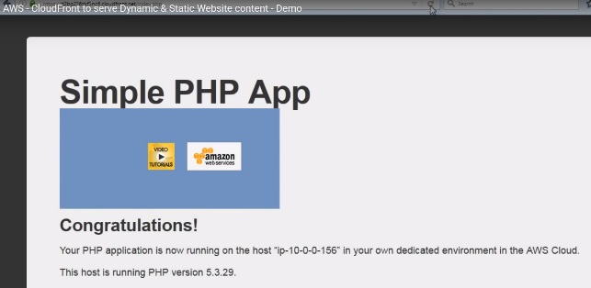

5.)Access using CF URL..(round robin WORKS)

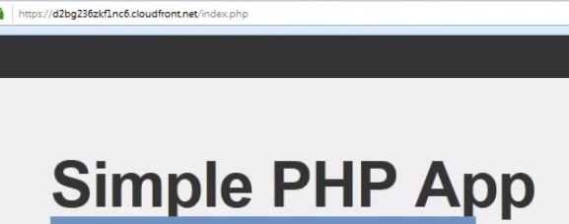-🡪 CF url

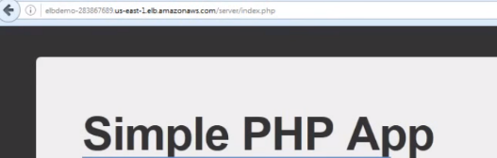**-🡪** When I access from ELB, I have to write server/index.php on ELB url.

All the static resources are accessed by CF url-🡪 so they get downloaded from edge locations…

* Note: if dynamic..php/jsp/aspx…you can setup origin as ELB.
* For all static 🡪 send to S3.
* Ensure in code, you are accessing all static assets using CF url only…

Sir ji, For the dynamic content you had set the ttl value '0' and you sent it to the ELB directly, Pls correct my understanding here. 1. So both static and dynamic are getting cached to the cloud front from the source, right? so it means, like the way we are caching the static content, we should be caching the dynamic content too right? so we shd have some TTL value? 2. When .i enable cloud front service, what happens behind, does amazon spin up a mirror image of my created infrastructure in the respective locations? what happens on the CDN data centre? coz, when my entire website is getting cached on a location nearer to the user and all the reads and writes go to the respective CDN instead of the source location!! thats amazing ..so i was curious .. what's getting spun there?﻿

REPLY

[Knowledge India](https://www.youtube.com/user/knowledgeindia)[1 year ago](https://www.youtube.com/watch?v=tqoDBNWBwas&lc=UgjA20C8n6k-n3gCoAEC.8RTvChWsJ488RUA8WunOhU)

1. TTL = 0, means do not cache. For Dynamic content, we do not cache at Edge Locations rather pass it to origin directly. Only Static assets are cached. In case of Dynamic content, the benefit is that of "traffic leaving Amazon network closer to customer". 2. There is no image created at Edge Locations. As i said only static assets are cached at Edge Locations, you can think of it as a facility to save files for some duration. Static assets are nothing but images, CSS, JS files etc.﻿

Read more

REPLY

[](https://www.youtube.com/channel/UCSZFSzBfQQzQ6PIDRzPRYIw)

[rangesh venkatesan](https://www.youtube.com/channel/UCSZFSzBfQQzQ6PIDRzPRYIw)[1 year ago](https://www.youtube.com/watch?v=tqoDBNWBwas&lc=UgjA20C8n6k-n3gCoAEC.8RTvChWsJ488RUI0nnmcyh)

ahhh got that , So basically , From the cloud front location amazon will have a dedicated connection to its primary/source AZ and so it wud be more optimal .﻿

1

REPLY

[Knowledge India](https://www.youtube.com/user/knowledgeindia)[1 year ago](https://www.youtube.com/watch?v=tqoDBNWBwas&lc=UgjA20C8n6k-n3gCoAEC.8RTvChWsJ488RUNHGCTLlP)

Yes. Amazon has its network in such a manner that if data flow happens from a Region to any Edge Location (or vice-versa) it would use Amazon's network and not public.﻿

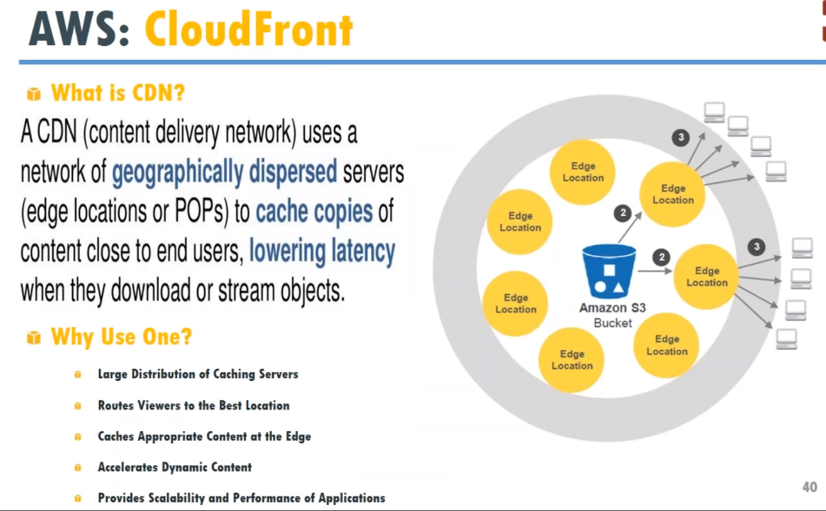

Think of bucket…with contents like media, text files, docs…

Think of laptops as end-users, that you want to share content across diff. geographical location.

What we do is: Copy content or clone content to all edge location or particular edge location and then distribute content..

**Advantages:**

1. Low latency, especially in terms of media streaming…Because we cant send 1st frame and then 2nd frame and then just to 4th frame…

In text/doc file, we can send bits in different order…But in media file, its have to be in sequence…

You have to send to end-users so that they don’t suffer from buffering..

1. You can also restrict movie in One region.

Ex: A movie is launched in US first and not in India…We can say…Users in india cannot access the contant that is already available in US.

1. Scaling capacity is offloaded by CDN provider.In this case: Amazon…
2. Amazon has lot of caching servers…Route at best location…And accelerate the dynamic content….

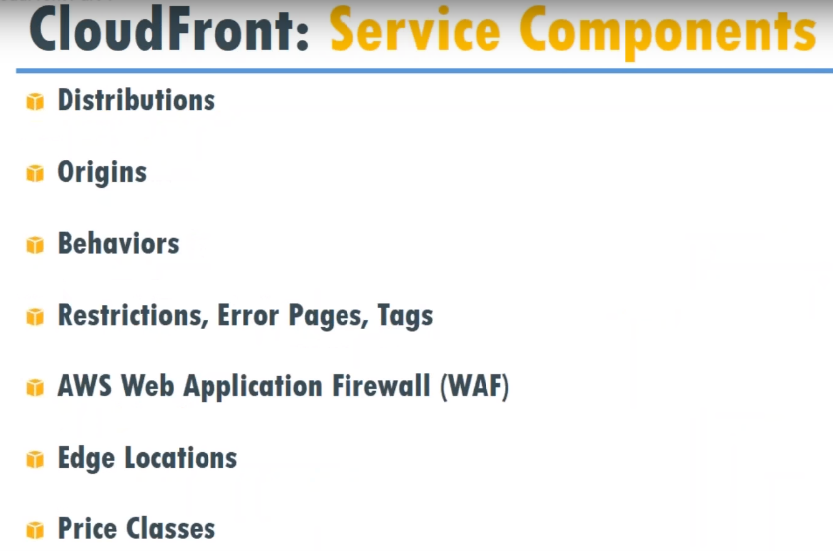

**Distributions:** What you are going to distributes.

* Static html
* Image
* Dynamic streaming file like video…Which constantly changes content freq…

We have 2 types of distributions.

1. Static
2. Dynamic/Streaming content

**Origin:** Where is origin of content???

-🡪From S3 bucket? Or Ec2 servers or On-premise DC???

**Behaviors:**

What happens when we do GET request.

When we type URL on browser, we are doing GET request...What should be done in CF??

When uploading file/PUT request…What should be done?

**Restrictions, Error pages, Tags:**

How do I restrict my page??

Based on geographic or access based restriction?

**access based restriction**: Lets say if my content is not public distributed, and distributed with company.

EX: HR releasing Holidays list at beginning of year…This is India holidays, optional and upload excel file on website..

If they are working on next year holiday they will be creating content.. But they don’t want to provide access to everybody for getting approvals within their team..

In this case, we can say access is restricted to certain group of individuals or people from this group..

**Geographic based restriction:** Restrict based on counties

**Error pages:**

We have error page..if contents not available or 404 error Then error page is displayed..We don’t want to display nasty page not displayed…etc.

We want to display some friendly pages..then we setup error pages..

**Tag Content**

Tagging for clean-up, budgeting, identifying..

**Price classes:** If we are distributing content to all across the globe…Then have to pay more than for certain regions..

**WAF (AWS Web application firewall) : Charged**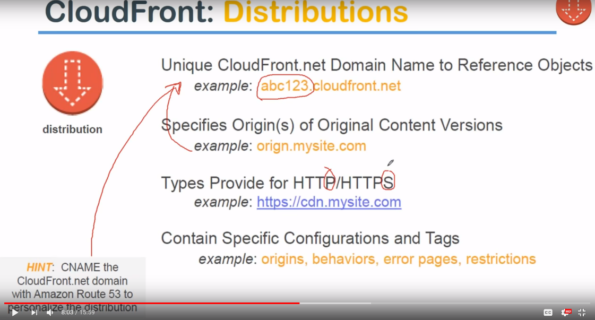

**Distribution:** We have origin coming from Own domain name.

Entry point to content ..We can distribute static/dynamic/Streaming content..

When we distribute, we get unique URL…Entry point

Alphanumeric.CLOUDFRONT.NET…Which is not easy to remember for end-users and clients.So, we use Route53 and fwd traffic from example.com to Alphanumeric.CLOUDFRONT.NET…

🡪Provide for http/https

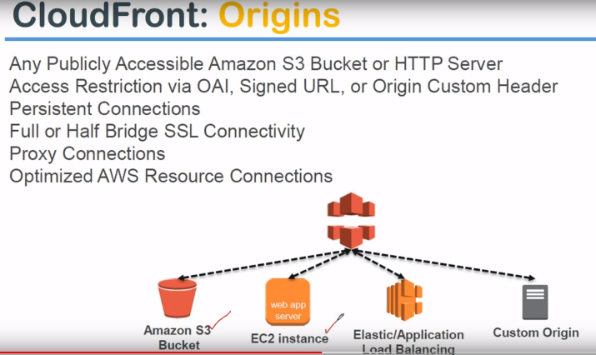

That is CloudFront icon..It can pickup data from S3/Ec2 or any application siting behind ELB(we point CF to ELB Domain name..It will automatically fwd to an Ec2 instances behind ELB)

Custom origin: On-premise DC.

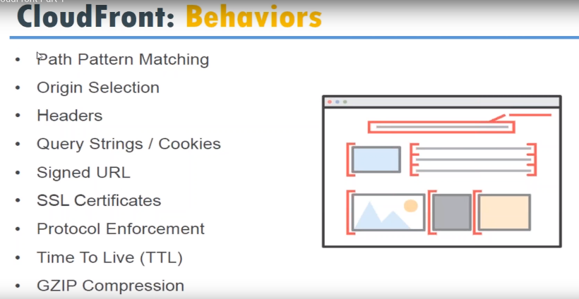

It consists of rules for processing HTTP requests.

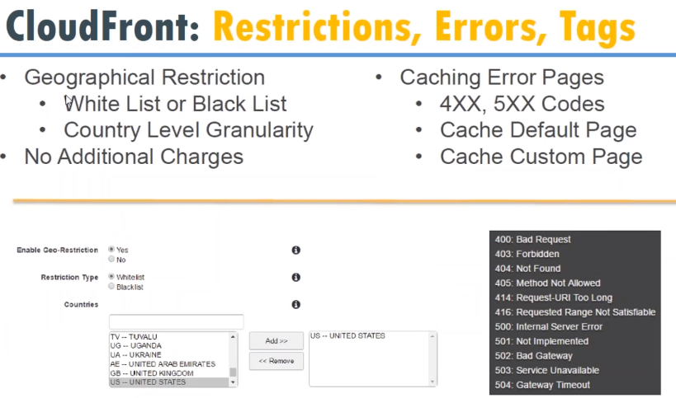

Blacklist or whitelist IP or countries..

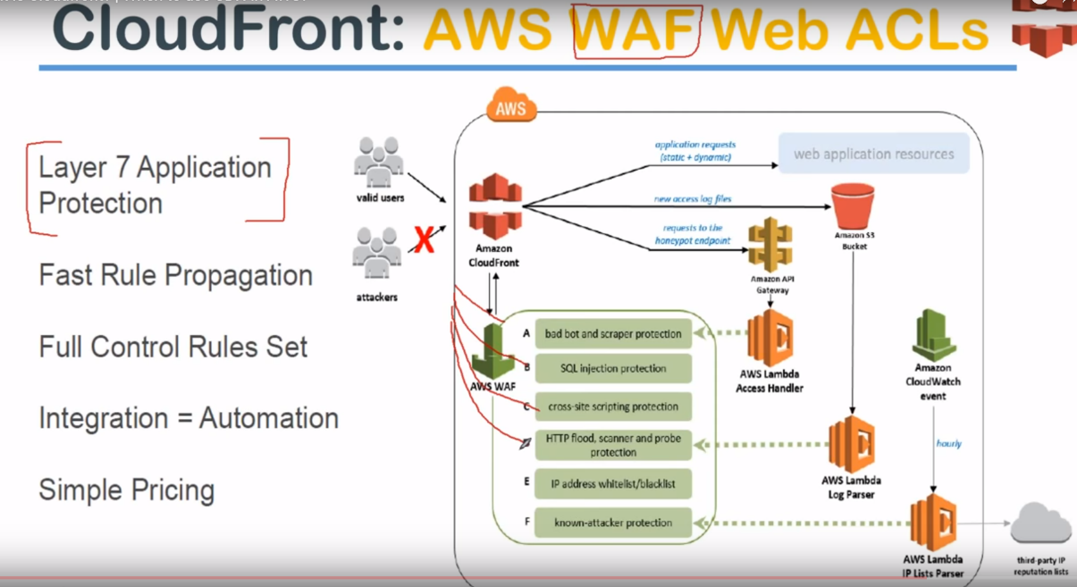

Ip address requesting for 1000 pages in 1 sec…HTTP floods(sending lot f request)

Sometime people try to scrape content online….Duplicate content on their own website.. We can apply firewall…

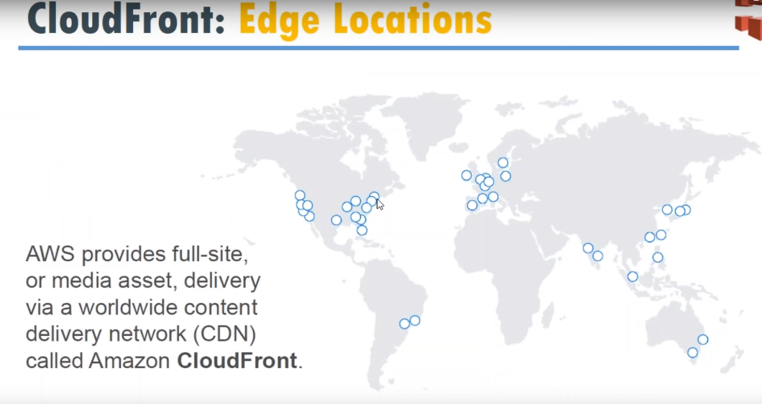

If we want to distribute contents to any of continents…Amazon automatically copes content to nearest Edge location…Copy to US, Copy to Asia or all locations…

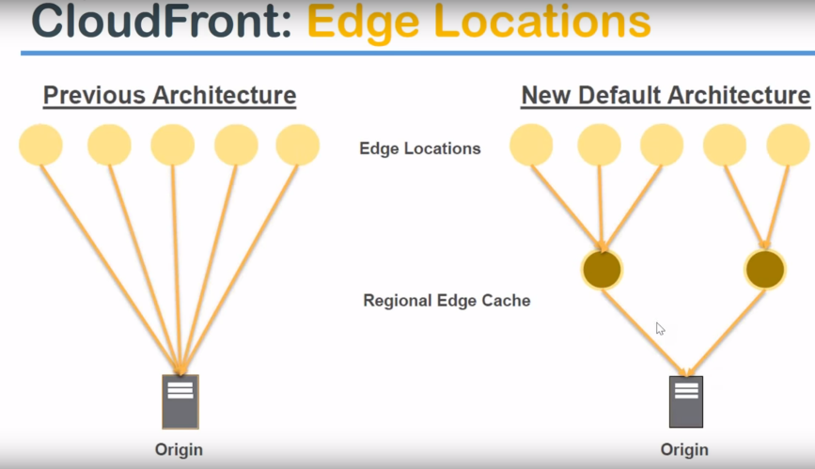

In some locations they have Edge cache…  
Lets say we want to distribute content…What amazon does is …Regionally cache at one Asia pacific and One at Americas…And from there they cache to different Edge locations..

Edge locations: Where we want to distribute traffic to…

Origin is where all the data is stored…f data is 1KB/1MB.., we can easily move to 100 + Edge locations all across globe..

Lets say we want to move 1 TB…Total 5 TB from source…Which will be huge Bandwidth cost.. So Amazon in Every local region, they created Regional Edge cache. Content will get distributed from Origin to Regional Edge Location ON YOUR COST…This BW is charged for us..

Moving from Regional edge to Edge locations…is borne by amazon..

Previously from origin, it used to got o edge locations directly…

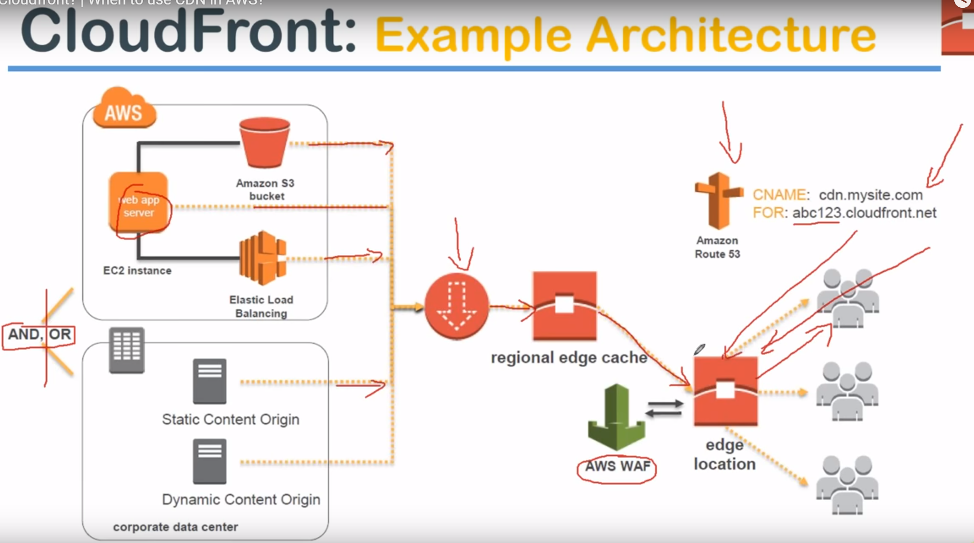

Left side: 2 boxes…top: Content residing in AWS.

Bottom: Content residing in On-premise..We can configure CF with Either or BOTH. We have multiple origins…like from Ec2 directly and S3 bucket.

Distribution sends data to regional Edge cache, which gets distributed to all other Edge locations ..

This is where WAF (web application firewall) comes into picture..

As End-user by typing in url(cdn.mysitecom)…, DNS will translate to abc.cloudfront.net …And browser will redirect to the edge location..

**DEMO**

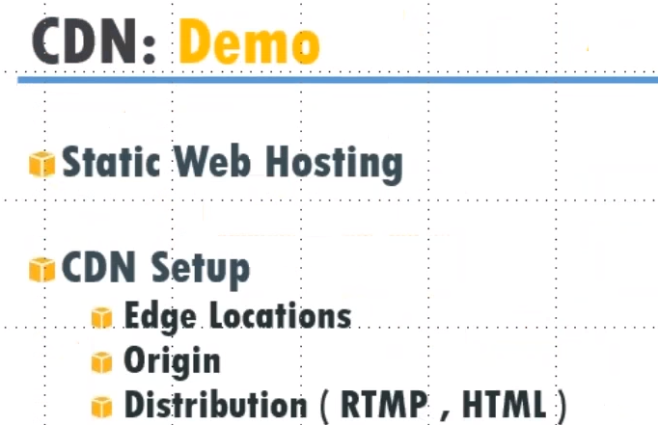

**1.)**

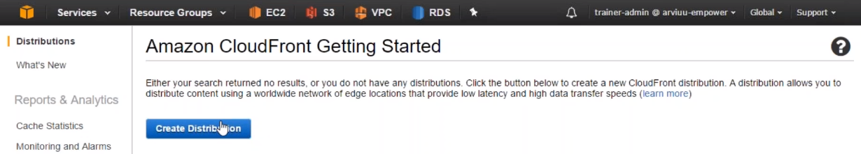

What kind of content we want to distribute??

2.)Web/RTMP(streaming) content?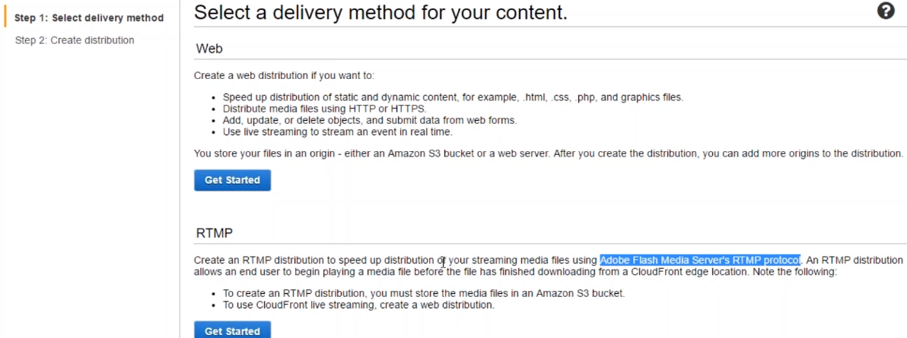

Amazon uses Adobe Flash media server RTMP protocol.

1. Origin: Where is content coming from??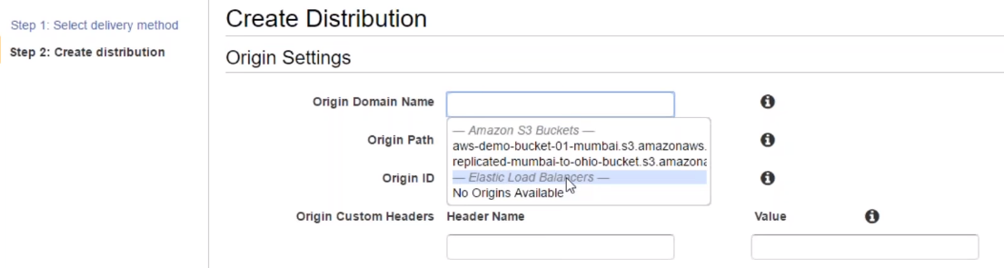

**Origin Domain name:** It gives options of S3 buckets and ELBs…If we have own domain name, we can type there…

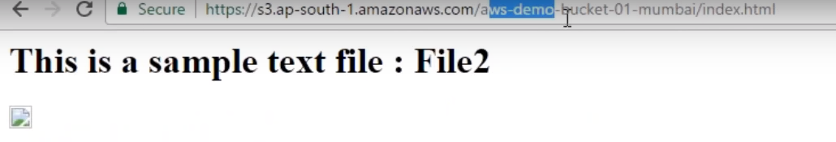

We are pointing o S3 bucket…AWS-Demo-Bucket-01.

**Origin Path:** We haven’t kept inside any sub-directory of bucket…

Origin ID: Automatically created from my bucketname.

Restrict Bucket access: No

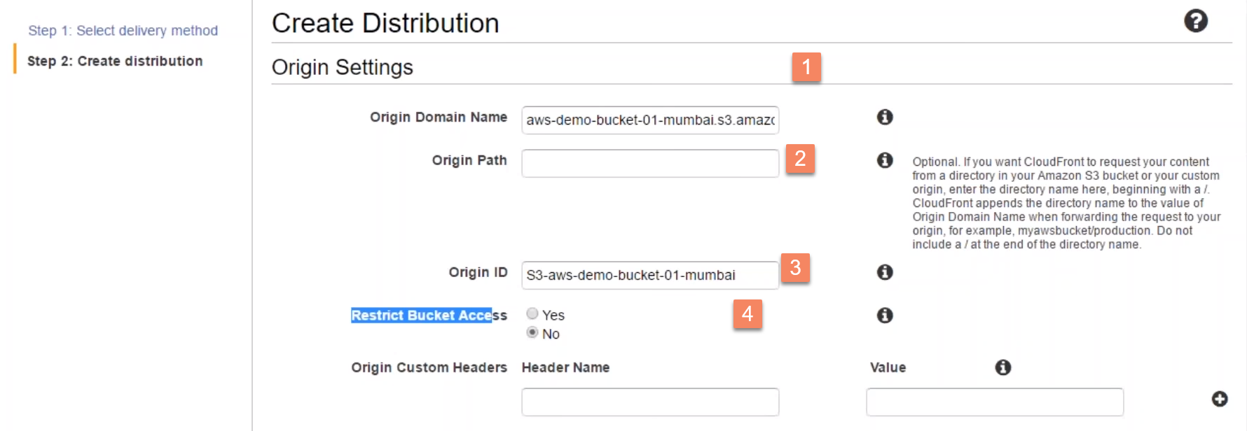

4.)

Default Cache behavior settings:

**You can leave everything default here..**

Choose HTTPS: If we want to secure traffic by using SSL certificate…

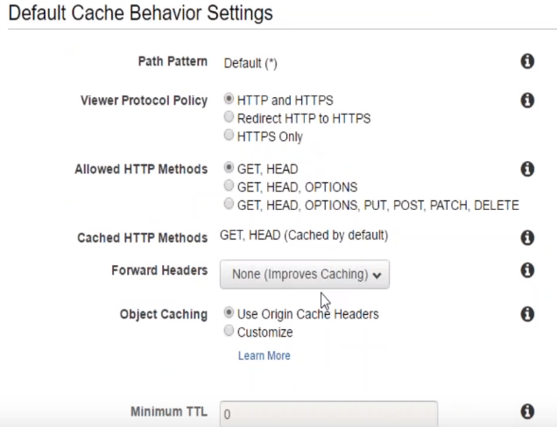 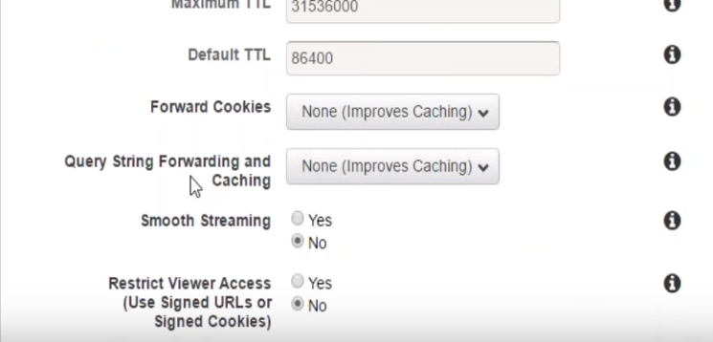

**5.) PriceClass: Where I want to cache my content..**

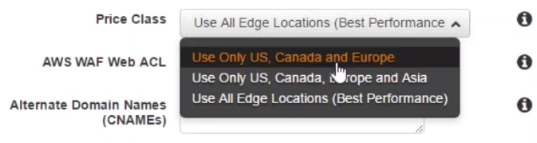-🡪Cheapest US

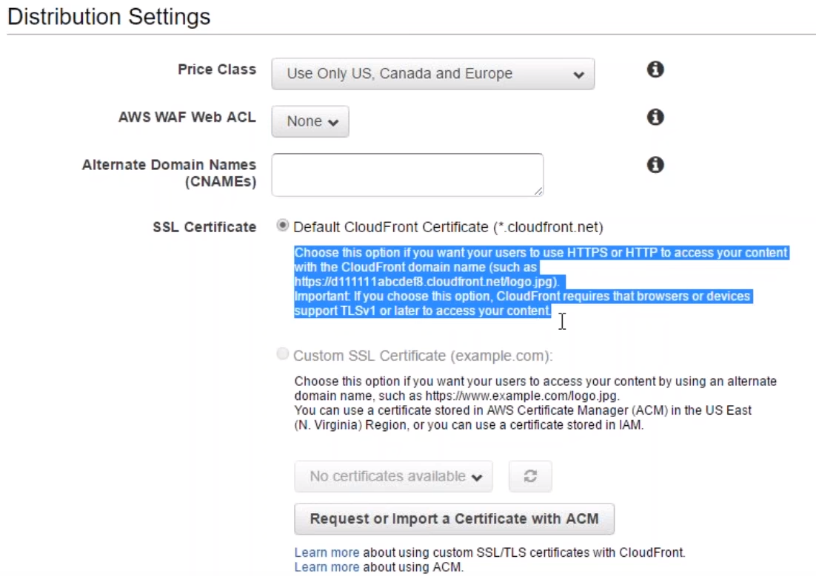

**Amazon itself creates SSL certificate and maintaian for us.**

**Leave everything default…**

**Logging: where I want to logto-🡪 I can choose S3 bucket**

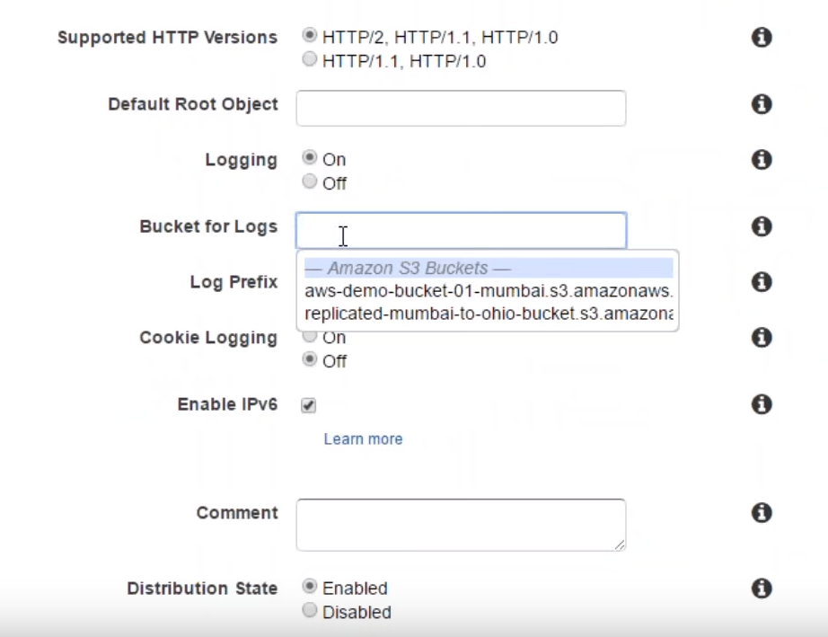



Also, we can add logs ---prefix…Example down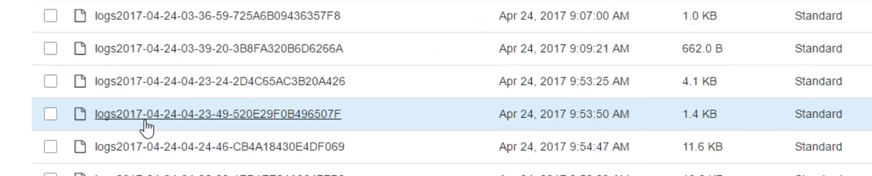

It takes time to process content and re-distribute all across edge-locations…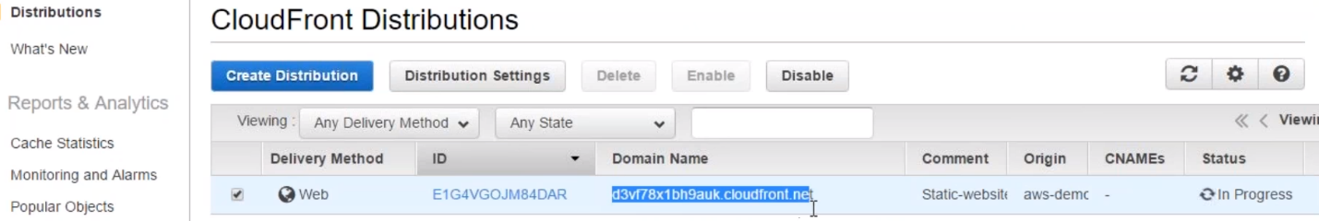

Try domain name in browser…

1.)To restrict to certain countries…

We can whitelist/blacklist which contry we want to allow content…No charges

Goto Restriction-🡪Enable Geo Restriction-🡪

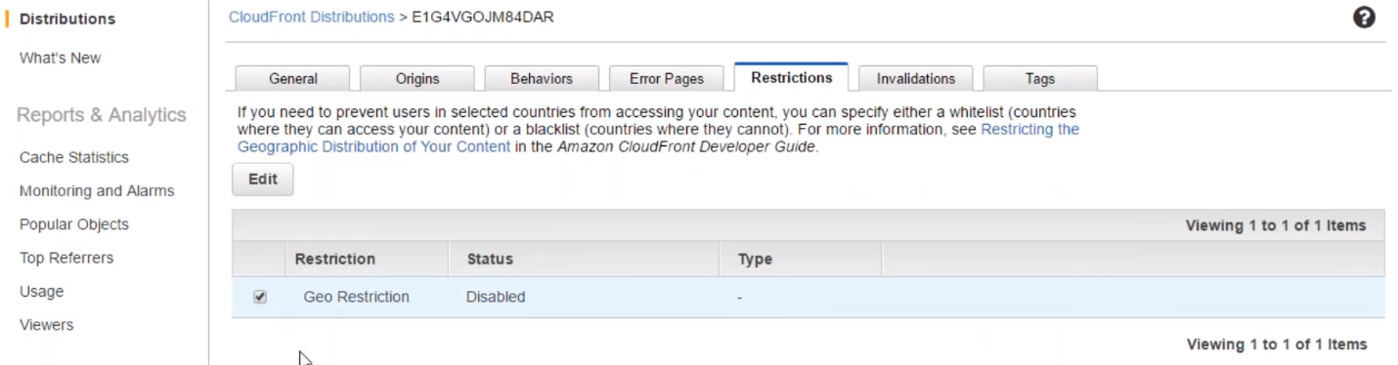

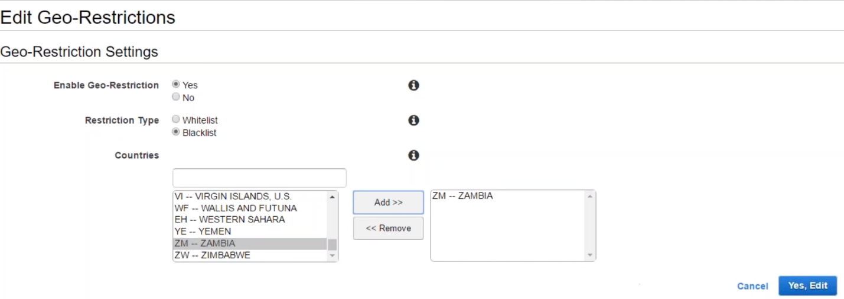

It will ask for contries to blcklist…Ex: People from Zambia don’t want to view my content..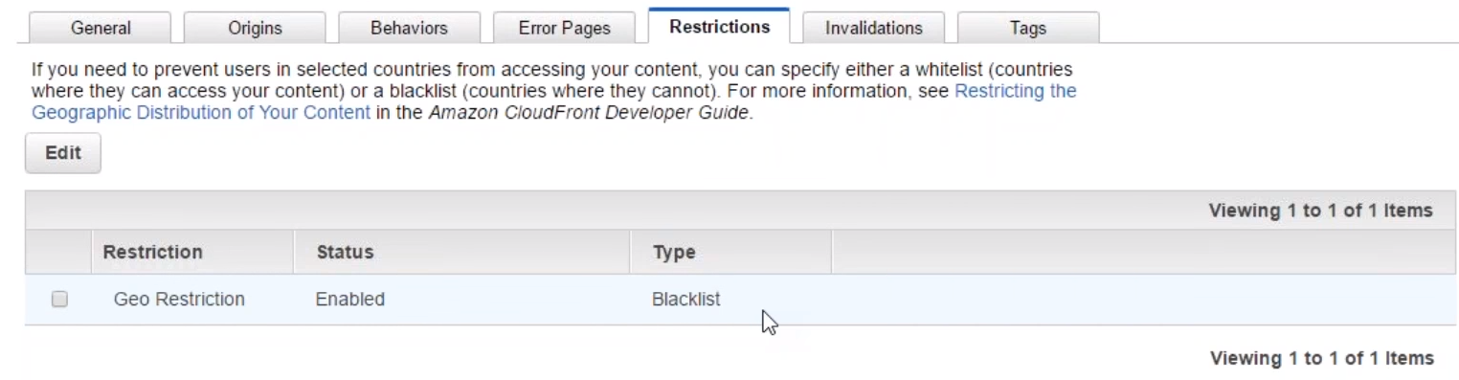

Blacklist is set now…

2.) Error Pages:

We can decide what error page we want to show…

If page is unavailale..Instead of showing 404 errror, you can fool your browser to think that you are sending http 200 message saying you look for abc paage…I ont have that page..But take error page..with code 2000--ok

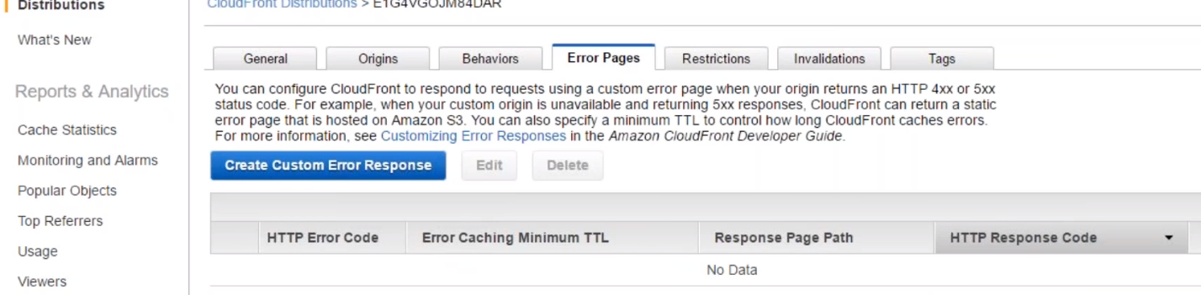

Create Custom error pages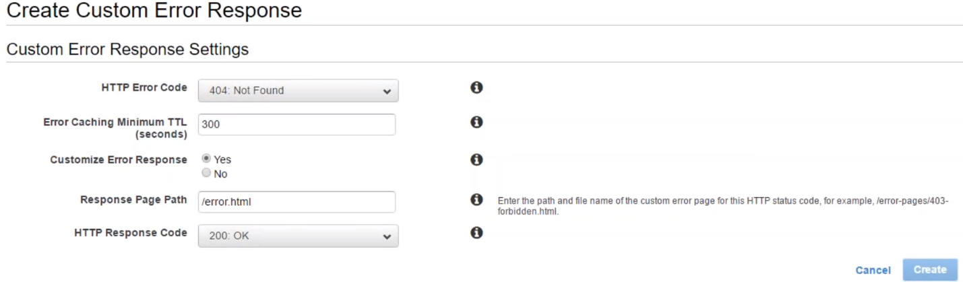

We are follong browser..everying OK here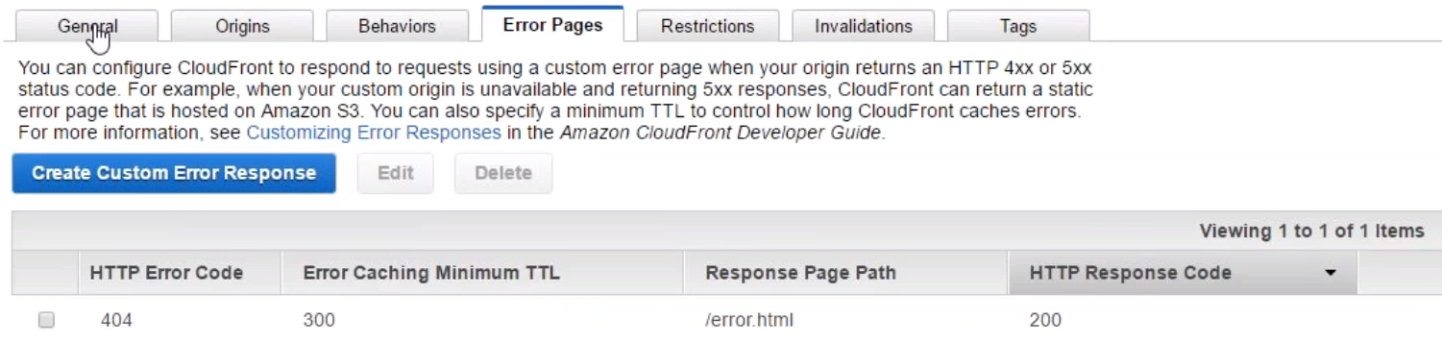

3.)Tags:

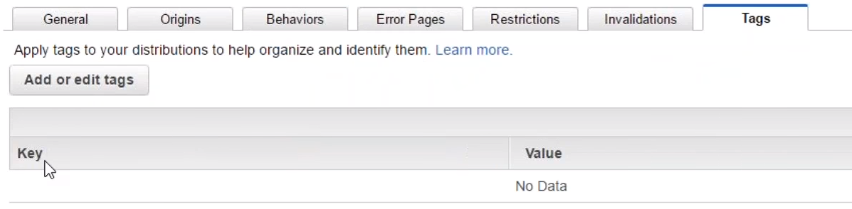

1. If we want to check certificate…

